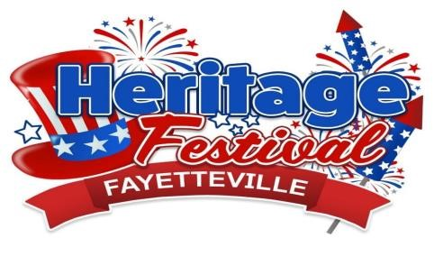



**Thursday – July 4th Festivities Downtown**

**10:00 a.m.-9:00 p.m.** Vendors - Downtown Fayetteville

**1pm-4pm 5pm-10pm** Carnival- The Charlie McCoy Town Park

**2:30 p.m.**  Old Fashioned Cake Walk & Youth Cookie Walk

**3:30 p.m.** Citizen of the Year Award & Hula Hoop Contest

**4:00 p.m.** Balloon Toss

**5:00 p.m.** The Best Small-Town 4th of July Parade- Maple Ave. Downtown

**6:00 p.m.** Sack Race

**6:30 p.m.** Frog Jumping Contest

**6:00 p.m. - 9:00 p.m.** Street Dance- Exiles Band Court St. Stage Downtown

**Friday - July 5th** **Festivities at The Charlie McCoy Town Park**

**10:00 a.m. - 9:00 p.m.** Vendors – The Charlie McCoy Town Park

**1pm-4pm 5pm-10pm**  Carnival – The Charlie McCoy Town Park

**5:00 p.m.** Patriotic Pet Contest

**6:00 p.m. - 9:00 p.m.** Buddy Allen & Cheap River Band – Charlie McCoy Park

# Saturday - July 6th Festivities at The Charlie McCoy Town Park

**8:00 a.m. – 12:30 p.m.** Fayette County Courthouse Parking Lot

**10:00 a.m.** FHS Come Home Reunion

**10:00 a.m. - 9:00 p.m**. Vendors - The Charlie McCoy Town Park

**1pm-4pm 5pm-10pm** Carnival – The Charlie McCoy Town Park

**3:00 p.m. – 5:00p.m.**  Street Heat Band- The Charlie McCoy Town Park

**5:00 p.m.** Hot Dog Eating Contest Sponsored by Tudors Biscuit World

**6:00 p.m.- 9:00 p.m.** Exiles Band- The Charlie McCoy Town Park

[Fayetteville’s Heritage Festival – 4th of July Celebration - Visit Fayetteville WV](https://visitfayettevillewv.com/event/fayettevilles-heritage-festival-4th-of-july-celebration/)

## 