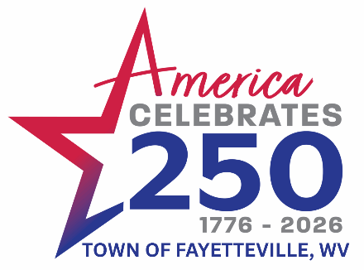




Friday - July 3rd Festivities Downtown
12:00 p.m.-9:00 p.m. Vendors- Downtown Fayetteville

12:00 p.m-3:00 p.m. Fayetteville Freedom 250 Soap Box Derby- Maple Ave- Downtown

5:00 p.m. Celebrating 250 Years of Freedom 4th of July Parade- Maple Ave. Downtown
Following Parade Old Fashioned Cake Walk & Youth Cookie Walk – In Front of Stage Downtown
7:00 p.m. Frog Jumping- Town Park

6:00 p.m.-8:00 p.m. Facepainting
6:00 p.m. - 9:00 p.m. Exiles Band – Stage Town Park

Saturday - July 4th Festivities at the Charlie McCoy Town Park
8:00 a.m. – 12:30 p.m. Fayette County Farmers Market -Courthouse Parking Lot
11:00 a.m. - 9:00 p.m. Vendors – The Charlie McCoy Town Park
11:00 a.m.-9:00 p.m. Inflatables -Baseball Field Town Park $5 Day Pass
2:00 p.m. Hula Hoop Contest- Town Park
2:30 p.m. Sack Race- Town Park
3:00 p.m. Hot Dog Eating Contest Sponsored by Tudor’s Biscuit World- Town Park
3:30 p.m. Patriotic Pet Contest –Town Park

4:00 p.m. Balloon Toss- Town Park

4:00pm-9:00pm Mechanical Bull at Town Park

6:00 p.m.-8:00 p.m. Facepainting- Town Park
6:00 p.m.-9:00 p.m. Black Light Satellite Band
Fireworks at Dusk Fireworks
